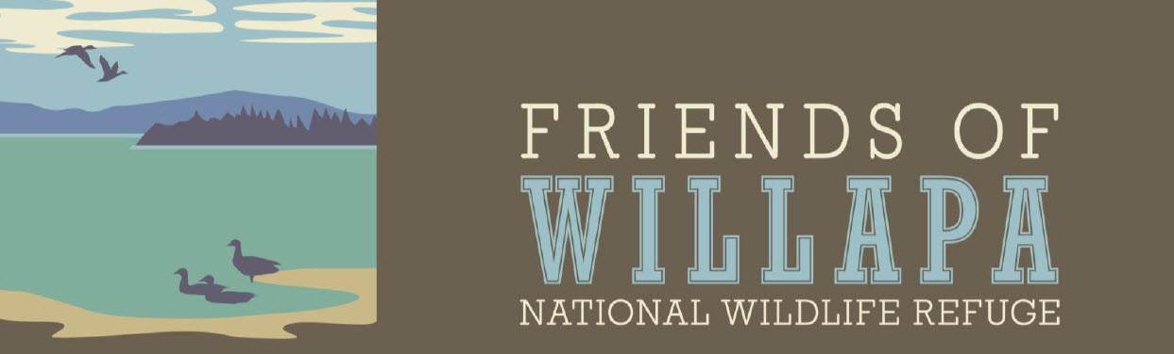

☐ NEW MEMBER ☐ RENEWAL – only need name and any address or level change

Name Date

Address

City, State, Zip

Phone

Email
☐ I want to receive the Friend's newsletter and announcements.

MEMBERSHIP LEVELS
☐ $25 Individual ☐ $250 Red-legged Frog
☐ $40 Family ☐ $500 Pacific Brant
☐ $100 Sanderling ☐ $1,000 Roosevelt Elk (lifetime)

DONATIONS
☐ Scholarship Program $ ☐ Education Program $ ☐ Other $

TOTAL Amount Enclosed $
MAKE CHECKS PAYABLE TO: Friends of Willapa NWR
MAIL TO: Friends of Willapa NWR, PO Box 845, Ocean Park, WA 98640

I would like to volunteer for:

☐ Environmental Education
☐ Events and Programs
☐ Habitat projects
☐ Other – please specify
☐ Special Projects
☐ Trail Maintenance
☐ Wildlife Surveys and Monitoring

Questions? Membership@friendsofwillaparefuge.org
Friends of Willapa National Wildlife Refuge is a 501(c)(3) non-profit organization. Donations may be tax-deductible; please consult with your tax advisor.

